Supplementary Information
This document contains the supplementary material of the article entitled Energy crisis in Europe revamps the economic competitiveness of green chemicals.
S1. Economic assessment
In essence, we use data from process simulations to determine the energy and materials inputs and outputs as well as the necessary infrastructure associated with each chemical. We then estimate the OPEX and CAPEX expenditures for a reference year (2019), adjusting afterwards the results for other years using the CEPCI index to account for inflation. For the OPEX calculations, the natural gas and electricity prices are not adjusted for inflation but instead we consider its fluctuating price at any given point in time (monthly average), which is based on historical market values. The hydrogen cost is considered as an OPEX expenditure and estimated from the renewable electricity price and the electrolyzer cost.
S1.1. Ammonia. The inventories for both fossil and green ammonia are taken from the work done by D’Angelo et al.¹ and shown in Table S1. A graphic representation of the techno-economic model is illustrated in Fig. S1a and Fig. S1b for fossil and green ammonia, respectively. The prices of feedstock and utilities other than natural gas, electricity, and hydrogen are based on D’Angelo et al.¹. These prices (Table S2) are adjusted for inflation using the Chemical Engineering Plant Cost Index – CEPCI (from Table S3) when considering data for a different year². We consider the monthly average natural gas spot prices (i.e., prices for new contracts at the Title Transfer Facility (TTF) trading point) from World Bank³ (Fig. 1) and electricity prices from Ember⁴ (Fig. S2). Further, the levelized cost for on-shore wind and solar electricity and their corresponding capacity factors were retrieved from the International Renewable Energy Agency (IRENA) for 2019 to 2021 (except 2022)^{5–7}. Using these values, the levelized cost of hydrogen (LCOH) is calculated following as in D’Angelo et al.¹. Due to data gaps for 2022, we determine first the levelized cost of hydrogen for 2021 and then adjust it for inflation using the CEPCI (Table S3)². The levelized cost of electricity and hydrogen for the corresponding years are shown in Table S4 and Table S5, respectively. The LCOH calculations are described in Section S1.3.
Table S1. Inputs and outputs of the ammonia production process per t of ammonia produced. These values are extracted from the work done by D’Angelo et al.¹ and are used for our techno-economic model.
Material/energy stream | Fossil route | Green route
Feedstock
Natural gas [t] | 0.43 | -
Process water [t] | 0.83 | -
Nitrogen [t] | - | 0.82
Hydrogen [t] | - | 0.18
Utilities
Heating – natural gas [t] | 0.10 | -
Electricity [kWh] | 935.39 | 469.89
Cooling water [GJ] | 18.12 | 3.12
CO₂ emissions [t] | 1.43 | -

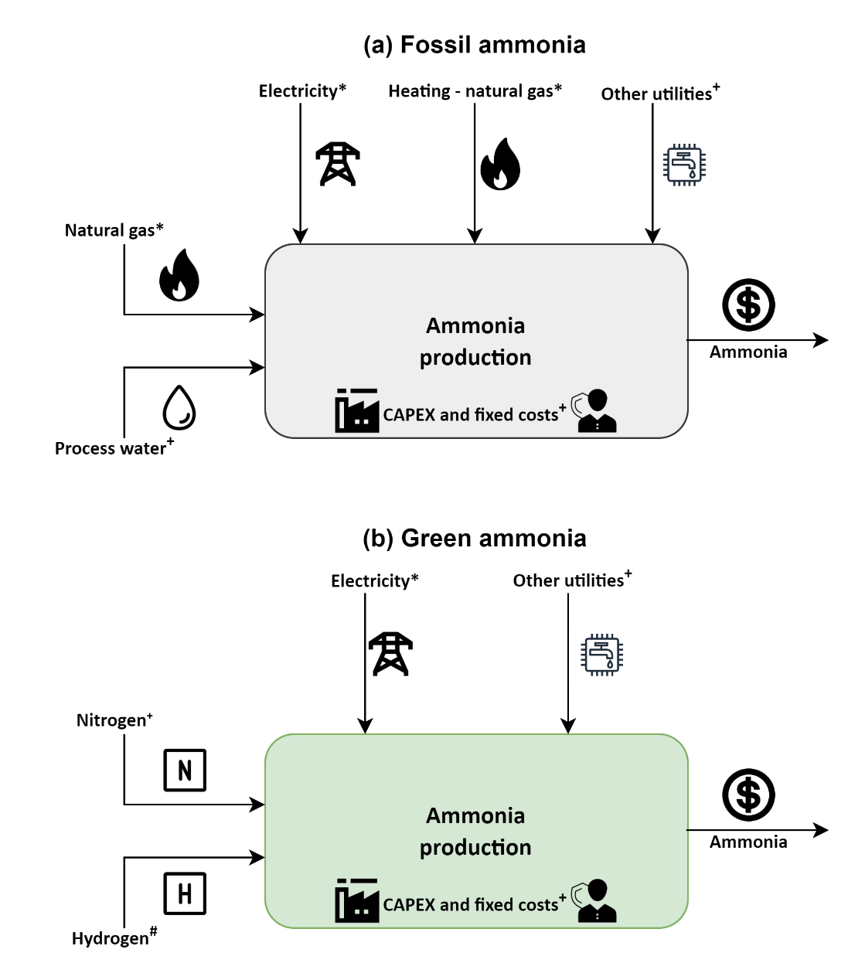
* - monthly average prices
+ - updated for inflation via CEPCI (prices can be found in Table S2)
# - LCOH from Table S5 (for methodology refer Section S1.3)
Fig. S1. Techno-economic model for the estimation of production costs for (a) fossil ammonia and (b) green ammonia. Other utilities include cooling water, CO₂ emissions, and wastewater treatment.
Table S2. Cost parameters used in the economic calculations for ammonia¹. All costs are presented in USD₂₀₁₉. These costs are further converted to USD₂₀₂₀₋₂₂ using the CEPCI index from Table S3.
Flow | Average | Low | High
Water [USD t⁻¹] | 0.18 | - | -
Cooling water [USD GJ⁻¹] | 0.38 | - | -
CO₂ emissions [USD t⁻¹] | 30.00 | - | -
Nitrogen [USD t⁻¹] | 91.06 | - | -

Table S3. CEPCI values from 2019 to 2022². All costs have been converted to USD₂₀₂₀₋₂₂ using the CEPCI, considering the reference year of 2019 (Table S2 and Table S7). Due to lack of availability of data, an average from January 2022 to September 2022 is considered as the CEPCI for 2022.
Year | CEPCI
2019 | 607.5
2020 | 596.2
2021 | 708.0
2022 (average till September) | 817.5

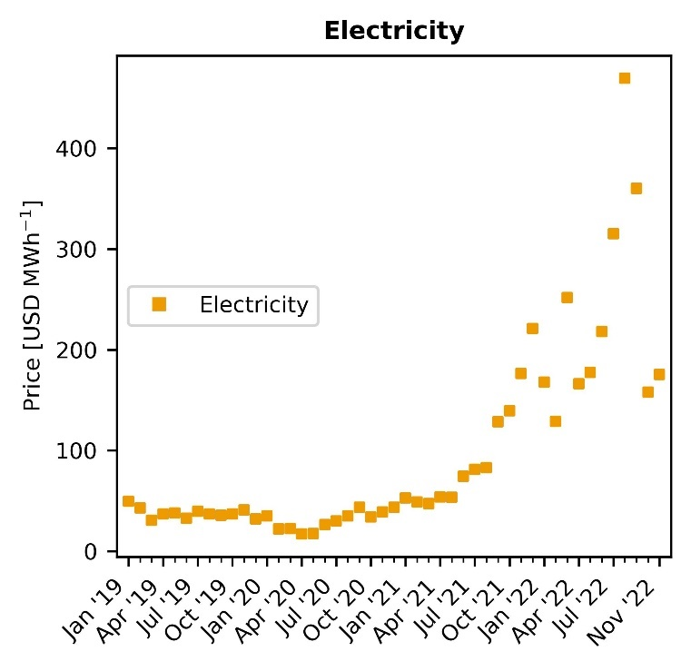
Fig. S2. Evolution of electricity prices in Europe⁴. Notably, electricity costs per MWh increased steadily since July 2021 following similar reasons as discussed in the case of natural gas (see Fig. 1). The monthly average prices of electricity along with natural gas are used in the techno-economic models for calculating the production cost estimates.
Table S4. Levelized cost of electricity (LCOE) in USD MWh⁻¹ and capacity factors (CF) in %^{5–7}. The LCOE and capacity factors are used to calculate the levelized cost of hydrogen (see Table S5). It should be noted that these values are specific to the location Europe.
 | 2019 |  |  |  | 2020
 | Average | Low | High | CF | Average | Low | High | CF
Wind - on shore | 67 | 37 | 96 | 35.6 | 45 | 35 | 65 | 36.0
Solar PV | 68 | 52 | 190 | 17.5 | 57 | 39 | 163 | 16.1

 | 2021
 | Average | Low | High | CF
Wind - on shore | 42 | 26 | 59 | 39.0
Solar PV | 48 | 29 | 120 | 17.2

Table S5. Levelized cost of hydrogen (LCOH) in USD t⁻¹. Section S1.3 provides a comprehensive explanation of the assumptions and methodology employed for computing the LCOH values.
 | 2019 |  |  | 2020
 | Average | Low | High | Average | Low | High
Wind - on shore | 6,882 | 5,232 | 8,477 | 5,636 | 5,086 | 6,736
Solar PV | 9,217 | 8,337 | 15,927 | 9,047 | 8,057 | 14,877

 | 2021 |  |  | 2022
 | Average | Low | High | Average | Low | High
Wind - on shore | 5,379 | 4,499 | 6,314 | 6,211 | 5,195 | 7,290
Solar PV | 8,212 | 7,167 | 12,172 | 9,482 | 8,276 | 14,055

S1.2. Methanol. The inventories for fossil and green methanol are similarly retrieved from González-Garay et al.⁸ and are shown in Table S6. Fig. S3a and Fig. S3b depicts a visual representation of the techno-economic model for fossil and green methanol, respectively. The prices of natural gas (Fig. 1), electricity (Fig. S2), and hydrogen (Table S5) are updated from the sources mentioned earlier in the case of ammonia, and all the other costs are adjusted for inflation (Table S7). The price of CO₂ from Direct Air Capture (DAC) is taken from Keith et al.⁹ and updated with the new natural gas (Fig. 1) and electricity prices (Fig. S2). It should be noted that the price of carbon dioxide is highly influenced by the natural gas and electricity prices as around 0.1 t of natural gas and 77 kWh of electricity is required per t of CO₂ captured.
Table S6. Inputs and outputs of the methanol production process per t of methanol produced. These values are extracted from the work done by González-Garay et al.⁸ and are used for our techno-economic model.
Material/energy stream | Fossil route | Green route
Feedstock
Natural gas [t] | 0.51 | -
Process water [t] | 0.85 | -
Carbon dioxide - DAC [t] | - | 1.45
Hydrogen [t] | - | 0.19
Utilities
Heating – natural gas [t] | 0.15 | -
Electricity [kWh] | 74 | 300
Cooling water [GJ] | - | 4.95

Table S7. Cost parameters used in the economic calculations for methanol⁸. All costs are presented in USD₂₀₁₉. These costs are further converted to USD₂₀₂₀₋₂₂ using the CEPCI index from Table S3.
Flow | Average | Low | High
Steam [USD t⁻¹] | 15.60 | - | -
Cooling water [USD m⁻³] | 0.03 | - | -
Catalyst [USD t⁻¹] | 136.38 | - | -
Wastewater treatment [USD m⁻³] | 1.64 | - | -
Carbon dioxide from DAC [USD t⁻¹] | 137.35* | 67.85* | 206.50*
*These prices do not include the natural gas and electricity cost required to capture carbon dioxide.

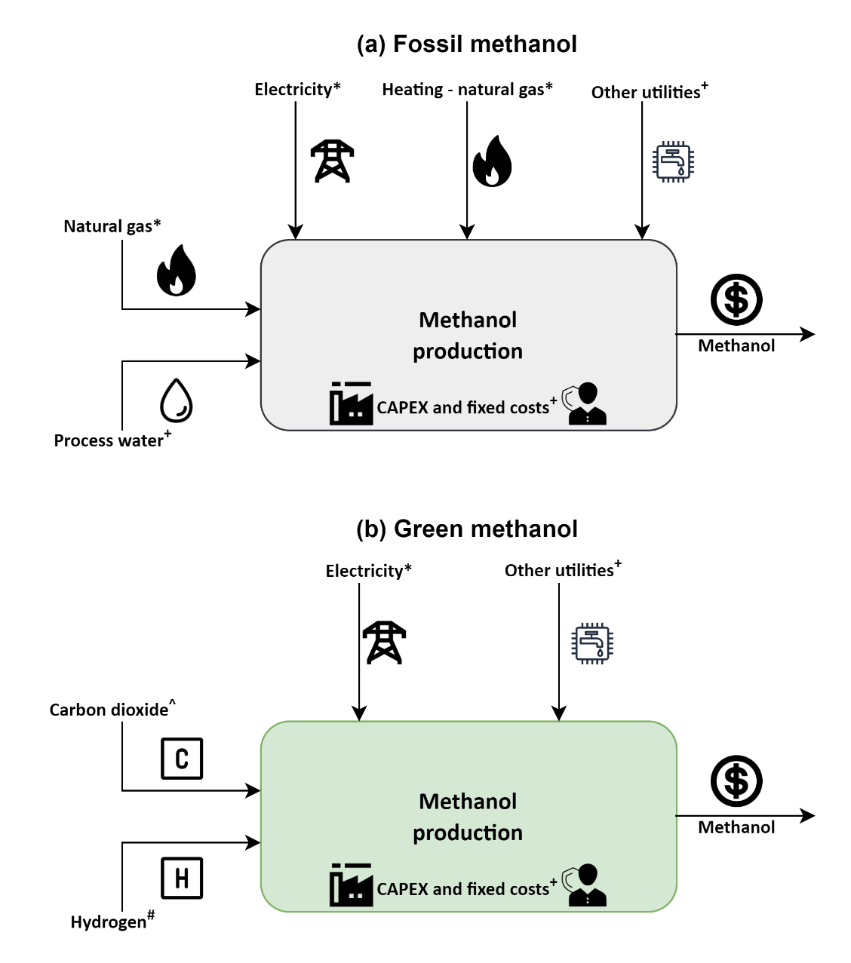
* - monthly average prices
+ - updated for inflation via CEPCI (prices can be found in Table S7)
# - LCOH from Table S5 (for methodology refer Section S1.3)
^ - updated with monthly average natural gas and electricity prices (see Section S1.2)
Fig. S3. Techno-economic model for the estimation of production costs for (a) fossil methanol and (b) green methanol. Other utilities include cooling water, wastewater treatment.
S1.3. Levelized cost of hydrogen (LCOH). The parameters used to calculate the LCOH for all on-shore wind and solar-based scenarios are shown in Table S8. A Proton Exchange Membrane (PEM) electrolyzer with a stack lifetime of 60000 hours is considered for the analysis¹. The methodology used to calculate the LCOH for hydrogen production from water electrolysis using on-shore wind and solar electricity are as follows¹:
First, we calculate the life span of the PEM electrolyzer using the stack lifetime of 60000 hours and the capacity factors from Table S4 (Equation S1).
$$\text{Life span = }\frac{\text{stack lifetime ∙ 100}}{\text{annual hours of operation ∙ capacity factor}}$$ | (Equation S1)

The amount of hydrogen produced annually is then calculated assuming a nominal H₂ flow per stack (refer Table S8) using Equation S2.
$$\text{Annual} {\text{H}}_{\text{2}}\text{ production =} \frac{\text{nominal }{\text{H}}_{\text{2}}\text{flow per stack }\text{∙}\text{ stack lifetime}}{\text{life span}}$$ | (Equations S2)

Assuming a start capacity of 50%, the capital expenditure (CAPEX) is estimated using the capital cost and nominal input power employing Equation S3. Notably, the capital cost is with reference to the year 2019 and is updated for inflation using the CEPCI index from Table S3 when considering data for a different year.
$$\text{CAPEX =} \sum_{\text{i} \text{= -1}}^{\text{0}}{\frac{\text{nominal input power }\text{∙}\text{ capital cost }\text{∙} \frac{\text{start capacity}}{\text{100}}}{{\text{(1 + interest rate)}}^{\text{i}}}}$$ | (Equation S3)

The amount of hydrogen produced throughout the life span of the electrolyzer is then calculated using Equation S4. We assume that in the first year of operation the plant works at a 50% capacity. Therefore, only for the first year, the hydrogen produced is multiplied by a factor of 0.5.
$${\text{H}}_{\text{2}}\text{ produced = }\sum_{\text{i} \text{= 1}}^{\text{life span}}{\frac{\text{annual }{\text{H}}_{\text{2}}\text{production }\text{∙} {\text{H}}_{\text{2}}\text{ production capacity}}{{\text{(1 + interest rate)}}^{\text{i}}}}$$ | (Equation S4)
$$\text{with }{\text{H}}_{\text{2}}\text{ production capacity= }\left\{ \begin{aligned}\text{0.5 i} \text{=} \text{1} \\ \text{1}\text{.0}\text{ i} \text{>} \text{1}\end{aligned}\right.$$
In the next step, the total operating costs (OPEX) are calculated by summing the electricity costs (Equation S5) using the LCOE from Table S4, other costs as 4% of initial CAPEX (Equation S6), plant decommissioning as 10% of initial CAPEX (Equation S7), and equipment replacement costs as 15% of depreciable CAPEX.
$$\text{Electricity cost} \text{=} \text{power demand electrolyzer }\text{∙}\text{ LCOE }\text{∙} {\text{H}}_{\text{2}}\text{ produced}$$ | (Equation S5)

$$\text{Other costs =} \sum_{\text{i} \text{= 1}}^{\text{life span}}{\frac{\text{nominal input power }\text{∙ }\text{capital cost }\text{∙}\text{ other costs factor}}{{\text{(1 + interest rate)}}^{\text{i}}}}$$ | (Equation S6)

$$\text{Plant decommissioning =} \sum_{\text{i} \text{= 1}}^{\text{life span}}{\frac{\text{nominal input power }\text{∙}\text{ capital cost }\text{∙ }\text{decommissioning factor} }{{\text{(1 + interest rate)}}^{\text{i}}}}$$ | (Equation S7)

$$\text{Equipment replacement costs} \text{=}$$  $$\sum_{\text{i} \text{= 1}}^{\text{floor(}\frac{\text{life span}}{\text{7}}\text{)}}{\frac{\text{nominal input power }\text{∙}\text{ capital cost }\text{∙ }\text{equipment replacement factor} }{{\text{(1 + interest rate)}}^{\text{i}}}}$$ | (Equation S8)

$$\text{OPEX} \text{=} \text{electricity cost} \text{+} \text{other costs} \text{+} \text{plant decommissioning} \text{+ equipment replacement costs}$$ | (Equation S9)

In the final step, the levelized cost of hydrogen (LCOH) is calculated by summing the CAPEX and OPEX and dividing by the total amount of hydrogen produced as shown in Equation S10.
$$\text{LCOH} \text{=} \frac{\text{CAPEX} \text{+} \text{OPEX}}{{\text{H}}_{\text{2}}\text{ produced}}$$ | (Equation S10)

Table S8. Parameters for the PEM electrolyzer¹. All values are in reference to the year 2019. These values are used to calculate the levelized cost of hydrogen using the methodology explained in Section S1.3.
Component | Value
Nominal input power [kW] | 5,000
Nominal hydrogen flow [kg hr⁻¹] | 89.88
Stack lifetime [hrs] | 60,000
Power demand electrolyzer [kWh Nm³_{H2}⁻¹] | 5
Capital cost [USD kW⁻¹] | 1,123.6
Interest rate [%] | 6.4
Other costs factor (fraction of initial CAPEX) | 0.04
Decommissioning factor (fraction of depreciable capital) | 0.10
Equipment replacement factor (fraction of initial CAPEX) | 0.15
Construction period [years] | 2
Start-up period [years] | 1
Start-capacity [%] | 50
Annual hours of operation | 8,760

S2. Avoidance costs
Using the methodology outlined in the methods section of the main manuscript, the calculation of the global warming potential (GWP) of various production routes for ammonia and methanol is performed. The activities used from the Ecoinvent v3.5¹⁰ database to calculate the global warming potentials (GWPs) are shown in Table S9.
Table S9. Inventories used from Ecoinvent v3.5 database¹⁰ for the background system. These activities are used to calculate the global warming potential and the avoidance costs for the different routes of production of ammonia and methanol.
Flow | Output | Activity in Ecoinvent v3.5¹⁰
Natural gas | Fossil ammonia and methanol, CO₂ from DAC, H₂ via SMR + CCS | Natural gas production
Process water | Fossil ammonia and methanol, CO₂ from DAC | Tap water production, conventional treatment
Grid electricity | All scenarios | Electricity, high voltage
Air separation facility | Nitrogen | Air separation facility construction
Cooling water | All scenarios | Water, cooling, unspecified natural origin
Solar electricity for water electrolysis | H₂ via solar | Electricity production, photovoltaic, 570kWp open ground installation, multi-Si
Wind electricity for water electrolysis | H₂ via wind | Electricity production, wind, >3MW turbine, onshore
Calcium carbonate for DAC technology | CO₂ from DAC | Market for calcium carbonate, precipitated
Heat from steam | Non-fossil methanol | Market for heat, from steam, in chemical industry
Wastewater treatment | Non-fossil methanol | Market for wastewater, average

S3. Model validation
The production cost estimates for fossil ammonia and methanol are validated with their respective market prices using the Pearson correlation coefficient (r). The model validation for ammonia and methanol is further explained in detail in Section S3.1 and S3.2, respectively.
S3.1. Ammonia model validation. The production cost estimates for ammonia calculated via techno-economic models were compared with the data extracted from Green Markets®¹¹ (Fig. S4). As the most reliable source for fertilizer pricing, and industry analysis, Green Markets® is a company under Bloomberg's umbrella¹¹. Green Markets® has recently published the market price of fossil ammonia from July 2019 to July 2022 for Western Europe. We use this data to validate our production cost estimates from techno-economic models. Fig. S4a show the evolution of Europe's market price and production cost (estimated in this work). In Fig. S4b, we compare the two data series using the Pearson correlation coefficient (r). The r value is found to be around 0.97 showing strong correlation between the two data series.
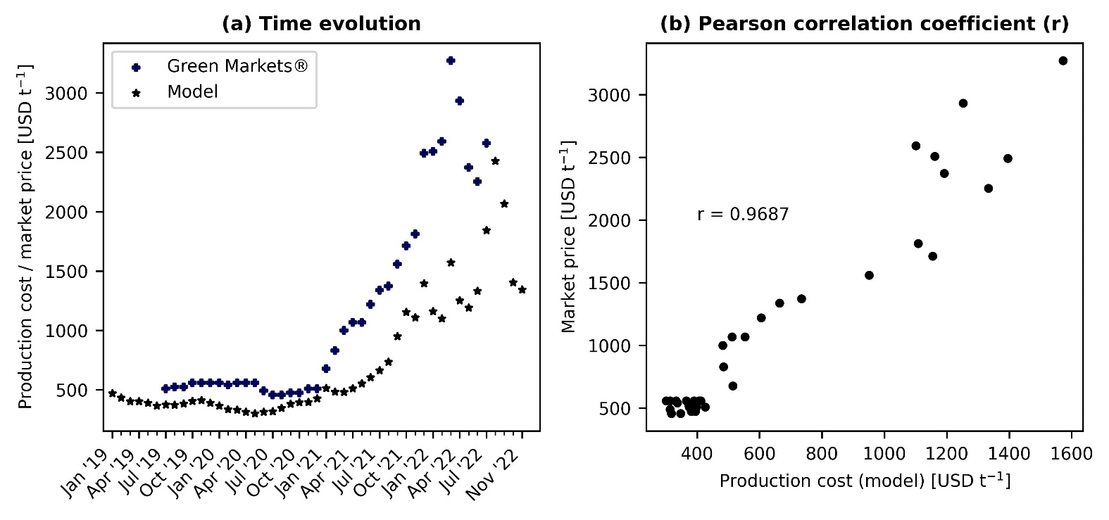
Fig. S4. Ammonia model validation. (a) shows the time evolution of the production cost estimates in comparison to the market price extracted from Green Markets®¹¹. (b) shows the correlation between the market price and the production cost estimate. A Pearson correlation coefficient (r) value of 0.97 is estimated showing strong correlations between the two data series.
S3.2. Methanol model validation. Market prices for European methanol were retrieved from Methanex Corporation¹² (January 2015 to November 2022). Methanex Corporation is the world’s largest producer and supplier of methanol to major international markets. Methanex has production sites in countries like Trinidad, New Zealand, Egypt, Canada, the United States, and Chile. Similar to ammonia, the data from Methanex is used to validate our production cost estimates from January 2015 to November 2022. The evolution of Europe’s market price and estimated production cost is depicted in Fig. S5a, as evaluated in this study. In Fig. S5b, the r value from January 2015 to July 2021 is calculated to be around 0.75 showing a sufficient correlation between the two data series. However, when the r value is calculated for the entire time range (January 2015 to November 2022), the coefficient decreases to 0.68. Also, as shown in Fig. S5a, there is a visible difference between the market price and estimated production cost for fossil methanol from July 2021. This difference is thought to exist due to the following reasons:
- Methanex has production sites in countries not affected by the current volatility of natural gas prices and hence produce methanol at a much lower price. When this methanol is exported to Europe, the market price is expected to be lower than the cost of production in Europe where the natural gas prices are the most impacted.

- Our model uses monthly average spot prices of natural gas TTF. Companies might not buy natural gas at these prices, as they might rely on established contracts. However, we would expect that the price of natural gas agreed upon in deals closed since the outbreak of the energy crisis would depend on the natural gas TTF index. Therefore, our estimates do not correspond to actual market values, but to the minimum selling prices in the market if those chemicals were produced in EU at the corresponding natural gas prices.

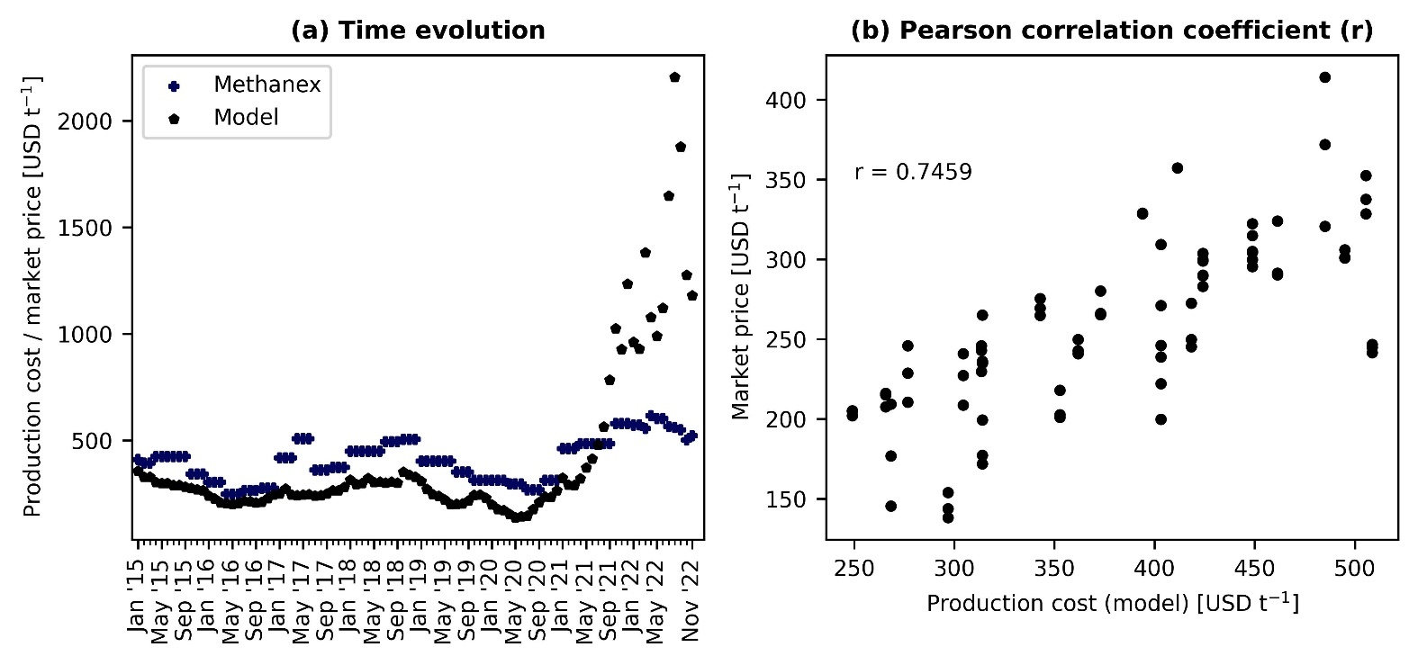
Fig. S5. Methanol model validation. (a) shows the time evolution of the production cost estimates in comparison to the market price extracted from Methanex¹². (b) shows the correlation between the market price and the production cost estimate. A Pearson correlation coefficient (r) value of 0.75 is estimated for the time period January 2015 to July 2021 (shown) and 0.68 for the time period January 2015 to November 2022 (not shown).
S4. Additional results
Due to space limitations, some additional results were not included in the main manuscript. This section presents those omitted results.
S4.1. Breakdown of production costs. Fig. S6a and Fig. S6b illustrates the cost breakdown for the production of ammonia and methanol through fossil and green routes.

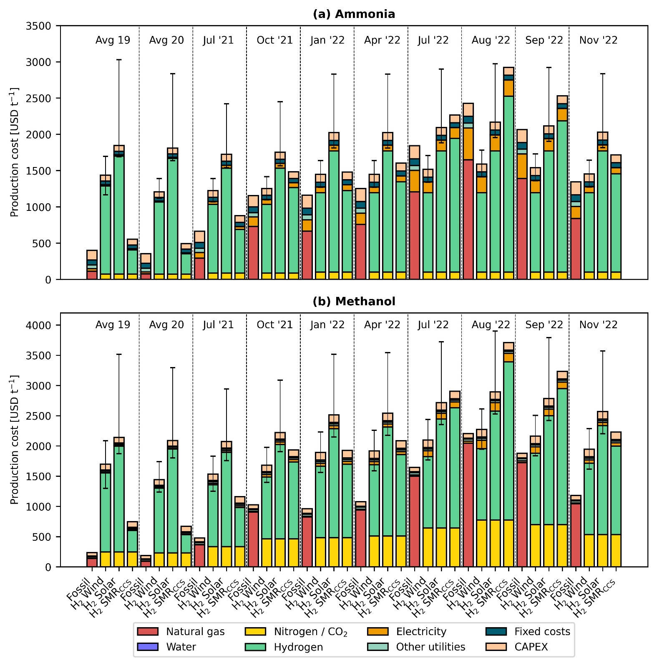
Fig. S6. Breakdown of production costs for fossil and green ammonia (a) and methanol (b). Error bars display the production cost considering the lower and upper bound for the levelized cost of hydrogen. Of all the components, hydrogen makes the greatest contribution to the average production cost of green chemicals.

References
1 S. C. D’Angelo, S. Cobo, V. Tulus, A. Nabera, A. J. Martín, J. Pérez-Ramírez and G. Guillén-Gosálbez, ACS Sustain. Chem. Eng., 2021, 9, 9740–9749.
2 C. Maxwell, Towering Ski., 2022.
3 W. Bank, World Bank, 2023.
4 Ember, Ember, 2022.
5 I. R. E. Agency, Renewable Power Generation Costs in 2019, Abu Dhabi, 2020.
6 I. R. E. Agency, Renewable Power Generation Costs in 2020, Abu Dhabi, 2021.
7 I. R. E. Agency, Renewable Power Generation Costs in 2021, Abu Dhabi, 2022.
8 A. González-Garay, M. S. Frei, A. Al-Qahtani, C. Mondelli, G. Guillén-Gosálbez and J. Pérez-Ramírez, Energy Environ. Sci., 2019, 12, 3425–3436.
9 D. W. Keith, G. Holmes, D. St. Angelo and K. Heidel, Joule, 2018, 2, 1573–1594.
10 G. Wernet, C. Bauer, B. Steubing, J. Reinhard, E. Moreno-Ruiz and B. Weidema, Int. J. Life Cycle Assess., 2016, 21, 1218–1230.
11 S. Gebre and E. Elkin, Europe’s Deepening Fertilizer Crunch Threatens Food Crisis, 2022.
12 M. Corporation, Methanex Corp.

